Lab Sheet 2

Date: - 29/03/2023

1. Accept two values from the user and display the sum of those two numbers on Screen

**Function reference Numbers:**

**1-for output Integer**

**4-for output string**

**5-Input the integer**

Explanation

**li $v0,5 # input A and save**

Load the system register,*$v0*, with the input code.

**syscall**

System call to accept an *integer* from the keyboard and store it in register *$v0*.

**move $t0,$v0**

Macro to transfer the contents of system register *$v0* to temporary register *$t0*.

**add $t0, $t0, $t1 # A = A + B**

Add the contents of *$t0* to the contents of *$y1* and place the sum in *$t0*.

**li $v0,1 # output sum**

Load the system register *$v0* with the output *integer* code.

**Accept two values from the user and display the sum of those two numbers on**

**screen.**

**# Program to add two numbers...**

.data

MSG1: .asciiz " The result is : "

MSG2: .asciiz " Enter the numbers : "

.text

main:

li $v0,4 //output string

la $a0,MSG2

syscall

li $v0,5 # input the first integer value

syscall

move $t3,$v0 // Put the integer value in t3 register

li $v0,5 # input the second integer value

syscall

move $t2,$v0 //Put it in t2 register

add $t1,$t3,$t2 //result of addition in t3

li $v0,4 // output string

la $a0,MSG1

syscall

li $v0,1 //print the integer value

move $a0,$t1

syscall

jr $ra

OUTPUT:

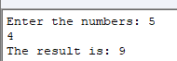

Write a MIPs program to find the sum of the first n numbers.

Code

*.data*

*msg1: .asciiz "\nNumber of integers (N)? "*

*msg2: .asciiz "\nSum = "*

*lf: .asciiz "\n"*

*.text*

*main:*

*li $v0,4 # output msg1*

*la $a0, msg1*

*syscall*

*li $v0,5 # input N and save*

*syscall*

*move $t0,$v0*

*li $t1, 0 # initialize counter (i)*

*li $t2, 0 # initialize sum*

*loop: addi $t1, $t1, 1 # i = i + 1*

*add $t2, $t2, $t1 # sum = sum + i*

*beq $t0, $t1, exit # if i = N, continue*

*j loop*

*exit: li $v0, 4 # output msg2*

*la $a0, msg2*

*syscall*

*li $v0,1 # output sum*

*move $a0, $t2*

*syscall*

*li $v0,4 # output lf*

*la $a0, lf*

*syscall*

*li $v0,10 # exit*

*syscall*

**Explanation**

**li $t1, 0 # initialize counter (i)**

Temporary register *$t1* contains the count.

**li $t2, 0 # initialize sum**

Temporary register *$t2* contains the sum.

**loop: addi $t1, $t1, 1 # i = i + 1**

Increment the counter by one.

**add $t2, $t2, $t1 # sum = sum + i**

Add the counter to the sum.

**beq $t0, $t1, exit # if i = N, continue**

If the counter equals the number of integers, then exit the loop.

**j loop**

Else perform the summation again.

**exit: li $v0, 4 # output msg2**

Statement to execute upon leaving the loop.

**Output:**

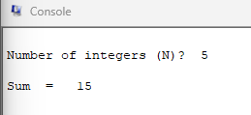

1. **Program to multiply two numbers.**

Code:

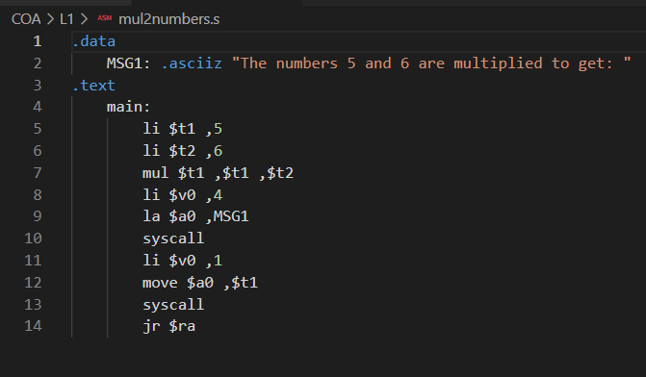

Output:

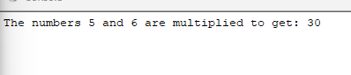

**Exercise for evaluation**

1. Accept two values from user and find the product of those two numbers.

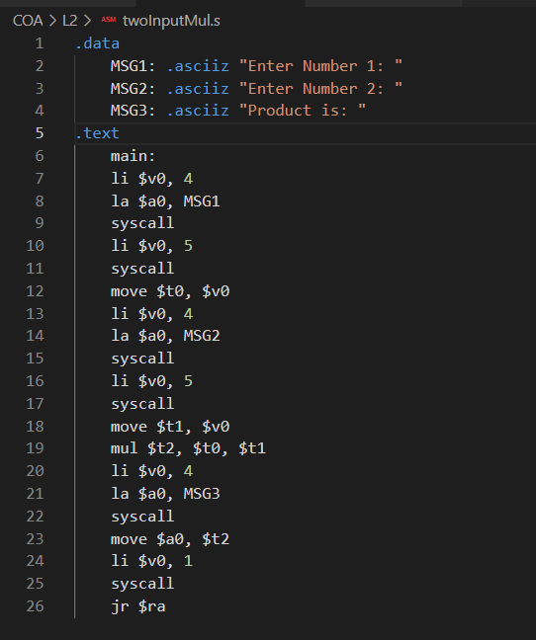

OUTPUT:

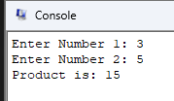

1. Write a program to find the product of first ‘n’ numbers and display it on screen.

Factorial

Code:

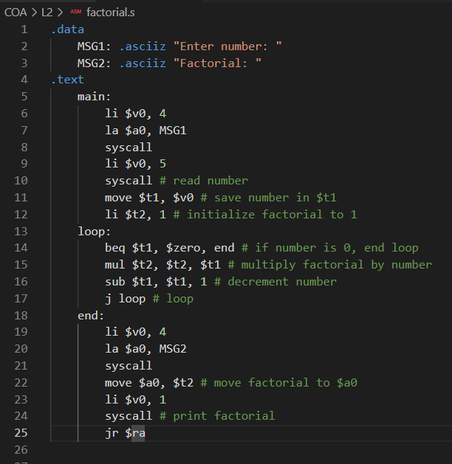

Output:

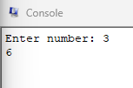

1. Perform division operation on two numbers. **Hint : - instruction is div**

**Code:**

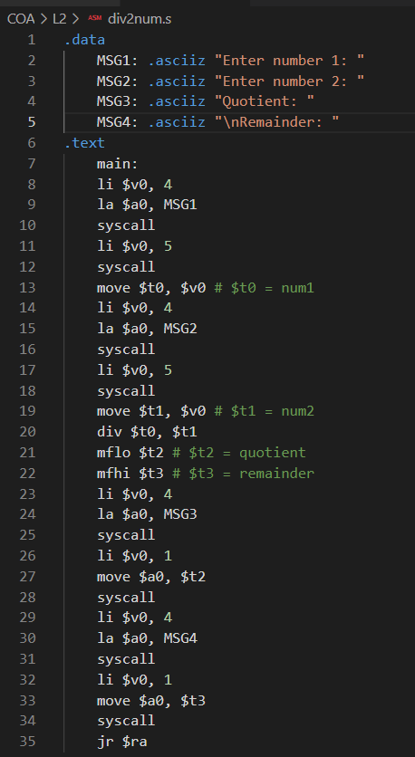

**Output:**



